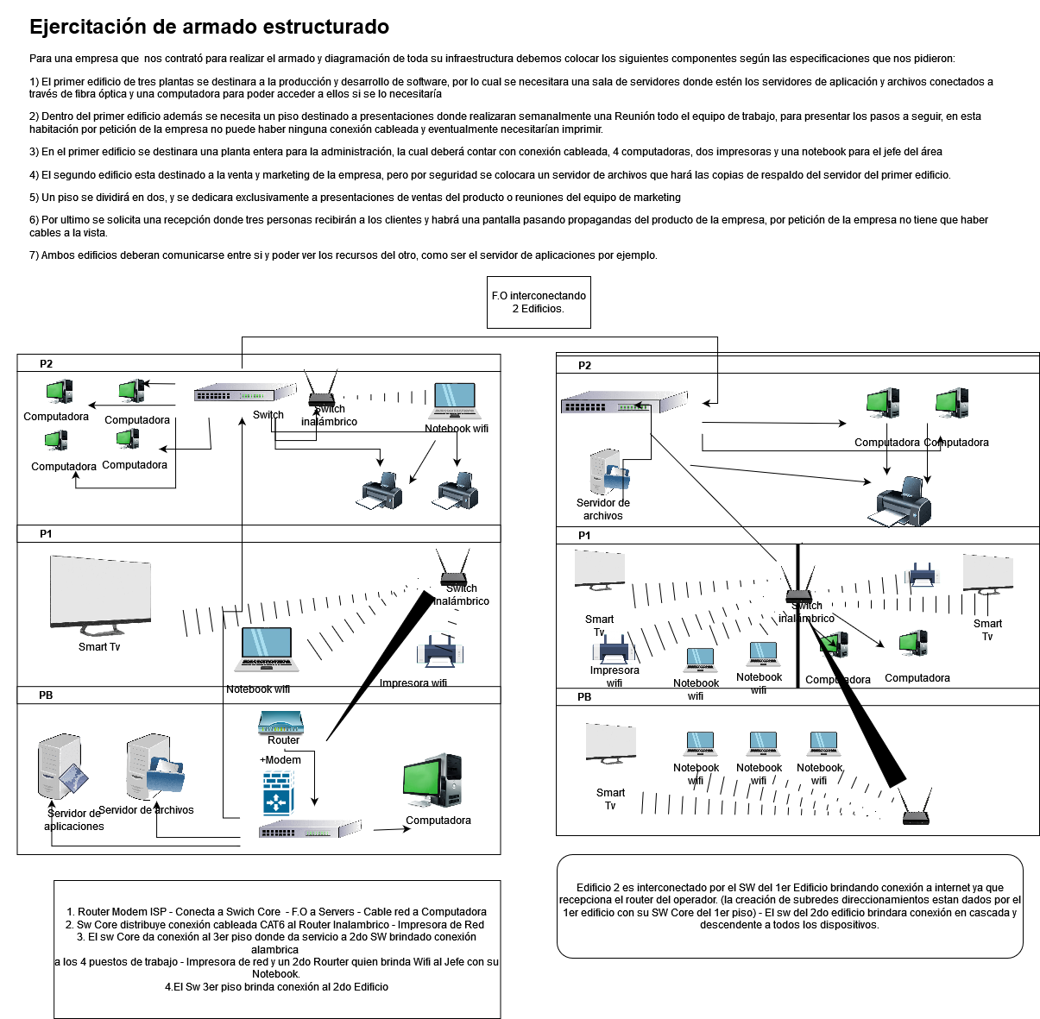

<https://app.diagrams.net/#G1_0wEfgqBfGWtYGSaFVz1nBzoK0wfT37h>